CPE 324-01: Advanced Logic Design Laboratory

Lab06

Digital to Analog Conversion using Pulse Density Modulation

Submitted by: Esther Shore

Date of Experiment(s): February 29, 2024 and March 5, 2024

Report Deadline: March 19, 2024

1. Introduction

In this laboratory experiment, we examine the usage of digital hardware to create periodic analog signals of various types. This is accomplished by controlling one of the FPGAs general purpose digital I/O pins and the signal processing algorithm of pulse density modulation. In Part A, we generate three different static waveforms and check for correctness using an oscilloscope and digital multimeter. For Part B, we modify the design to play back prerecorded audio through an amplified speaker connected to the DE2-115. Finally, we again modify our design to generate an amplitude modulated analog radio frequency signal that is amplitude modulated by our audio in Part C. We will also verify the functionality of our design using a standard AM broadcast band receiver since the frequency of the radio frequency signal is to be 1MHz.

1. Experiment Description

Part A: Analog Waveform Generator Evaluation/Simplification

This part of the experiment involves the analysis and modification of the existing configuration to observe and measure waveform generation. In the given code template, we uncomment the necessary code sections and synthesize three implementations to separately generate a square wave, triangle wave, and sine wave. We then modify our design so that it will generate a 1 KHz sawtooth waveform. Finally, we simplify the design by combining the Clock_en and Waveform_Gen procedural blocks into a single procedural block that is named Waveform_Gen2 as shown in Figure 1 below.

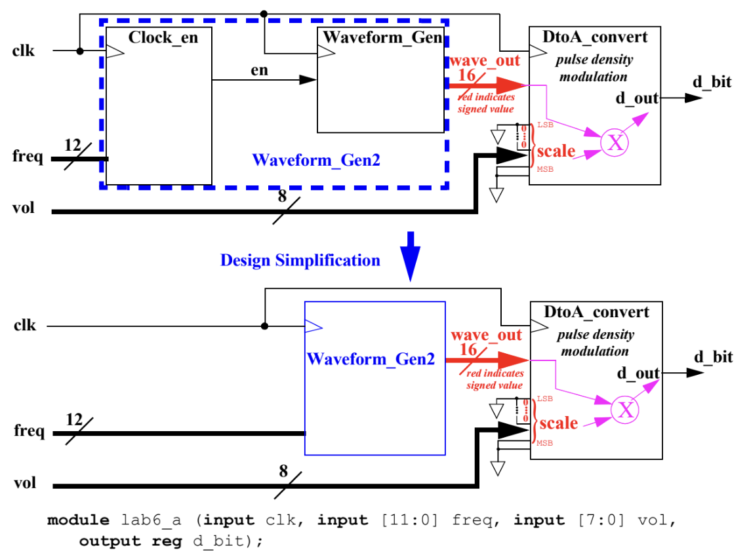

**Figure 1.** Design Simplification Diagram

In order to accomplish these tasks, we had to understand the concepts of pulse density modulation, which is a common signal processing technique that can be used to create high-fidelity audio output, and the overall analog waveform generator design using Verilog modeling constructs. The basic pulse width modulation algorithm was provided to us using signed fixed-point range analysis for the Verilog pdm task and digital to analog converter element, waveform generating element, and clock enabling element cyclic procedural implementations.

Part B: Audio Generator (8 KHz Sample Rate)

Building off the previous part, we construct an audio generator that can read in pre-recorded audio that has been sampled at 8000 Hz and stored in a text file in hexadecimal form, and output the audio on the connected speaker. In order to accomplish this, we modify the Waveform_Gen2 as Audio_Out, using the Verilog directive $readmemh to initialize a two-dimensional array with the encoded data elements from the input audio text file. The high-level design is shown in Figure 2 below. The design should also be able to handle both 8 bit and 16 bit versions of the audio files, which differ from one another by their resolution.

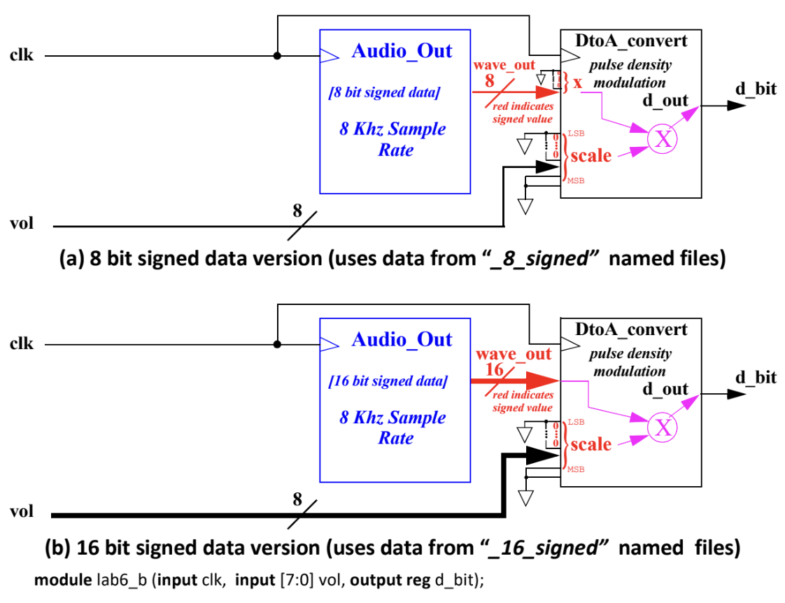

**Figure 2.** Audio Generator Design

Part C: Amplitude Modulation of a Radio Frequency Wave

This is the final portion of the laboratory where the previous two parts are combined to allow a sampled 1 MHz RF range sine wave to be amplitude modulated by 8 kHz sampled audio. This allows the audio to be broadcast at short distance wirelessly and received by a standard AM receiver. The audio waveform is offset by a constant then amplitude modulation occurs when sampled audio signal is supplied with the sampled higher frequency sine wave. A visual representation of the modulation process is shown in Figure 3.

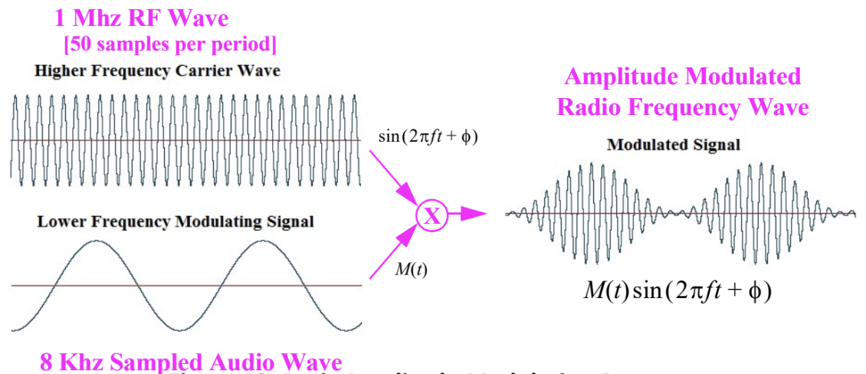

**Figure 3.** Basic Amplitude Modulation Process

The result of the modulation between the two waves is an alternating current, producing a radio wave that can be retrieved using the AM detector. The Audio_Out portion of the design is modified to do this so that it uses 8kHz sampled offset data and has it drive the wave_out2 internal signal, and the Wave_Out portion driven by the values from the 50 element sine lookup table from part A. The high-level design abstraction is displayed in Figure 4. It will be able to process both 8 bit and 16 bit data by driving least significant bits of DtoA_convert input to logic 0 for 8 bit data.

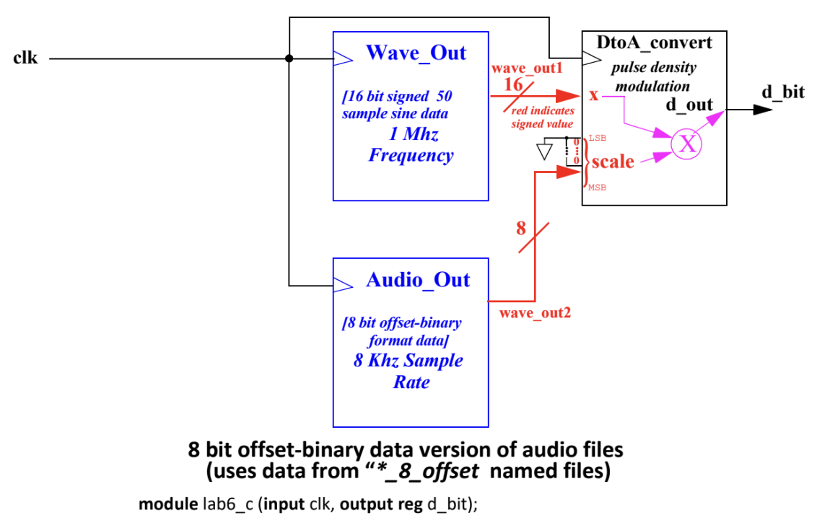

**Figure 4.** AM Transmission Generator Design

1. Demonstration

Part A: Analog Waveform Generator Evaluation/Simplification

This analog waveform generator design was fully implemented and evaluated on the DE2-115 board by assigning the clk input to the 50 MHz system clock, the vol input to SW17-SW10, the 10 MSB of the freq input to SW9-SW0, and the 2 LSB of the freq input to KEY3 and KEY2. The digital multimeter was set to measure volts with a scale range of 2 and the switches SW17 through SW10 all set high. We configured SW9 through SW0 and KEY3/KEY2 to be set in a manner that produced a 1 KHz signal as closely as possible. Experimentally, this was determined to be where SW1, 3, 4, 5, 6, 7 were all switched to the ON or logic high position. Using this configuration, we successfully generated the square, triangle, and sine waves using the provided code, recording the waveform characteristics and finally writing our code to generate the sawtooth waveform, which is displayed in Figure 5 below.

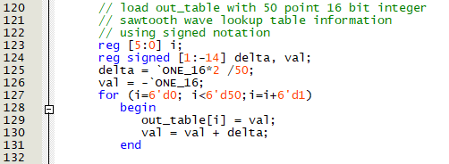

**Figure 5.** Sawtooth wave generation code

We also demonstrated the functionality of our simplified design from combining the Clock_en and Waveform_Gen procedural blocks into a single procedural block as shown below. Through the design simplification task, we removed the internal register en, resulting in a higher-level design that is more behavioral in nature than the two procedural blocks before combining them.

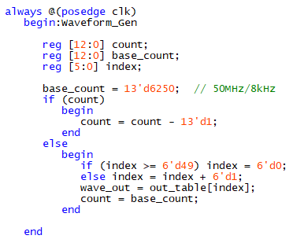

**Figure 6.** Simplified waveform generator design

The waveforms produced on the oscilloscope can be seen in the figures in the appendix.

Part B: Audio Generator (8 KHz Sample Rate)

We implemented at least one version of the audio playback design, ensuring that both 8 bit and 16 bit audio versions worked properly, demonstrating the playback of two separate audio files. It would continuously cycle through the audio clip and replay it when it reached the end of the clip. Our code can be viewed in Figure 7 below, where the base count was determined by dividing the FPGA clock frequency by the maximum audio frequency.

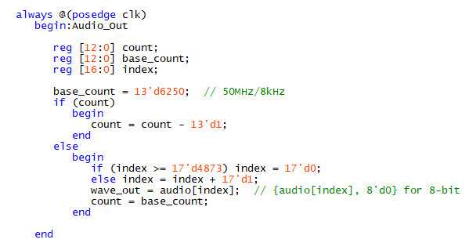

**Figure 7.** Audio generation code

We were able to process both 8 bit and 16 bit versions of the audio files by padding the lower order bits fed to DtoA_convert with logic 0’s.

Part C: Amplitude Modulation of a Radio Frequency Wave

To demonstrate the functionality of our amplitude modulation of a radio frequency wave experiment, we implemented at least one version of the AM transmission generator design and demonstrated the RF playback of two separate audio files. We ensured that our design worked for both 8 bit and 16 bit audio file inputs, where it continuously cycled through the audio clip and replayed it when it reached the end of the clip. The playback was received on a standard broadcast band AM radio when it was brought near the audio connector line of the DE2-115. The code for audio generation, waveform generation, and modulation is shown in the figure on the following page.

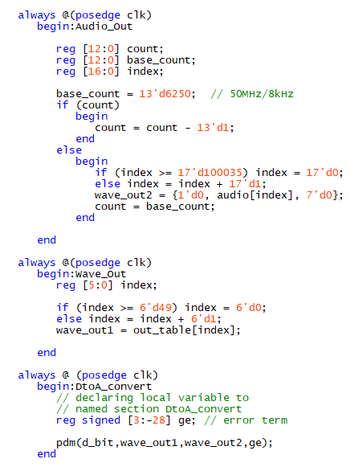

**Figure 8.** Audio modulation code

1. Experimental Results

Part A: Analog Waveform Generator Evaluation/Simplification

For each waveform generated, we viewed and recorded the shape, peak-to-peak voltage, and frequency on the oscilloscope. These results for the square, triangle, sine, and sawtooth waveforms can be examined in the following four figures. Our results were approximately what we expected, with consistent peak-to-peak voltages and a frequency of 1 kHz, matching the shape we anticipated.

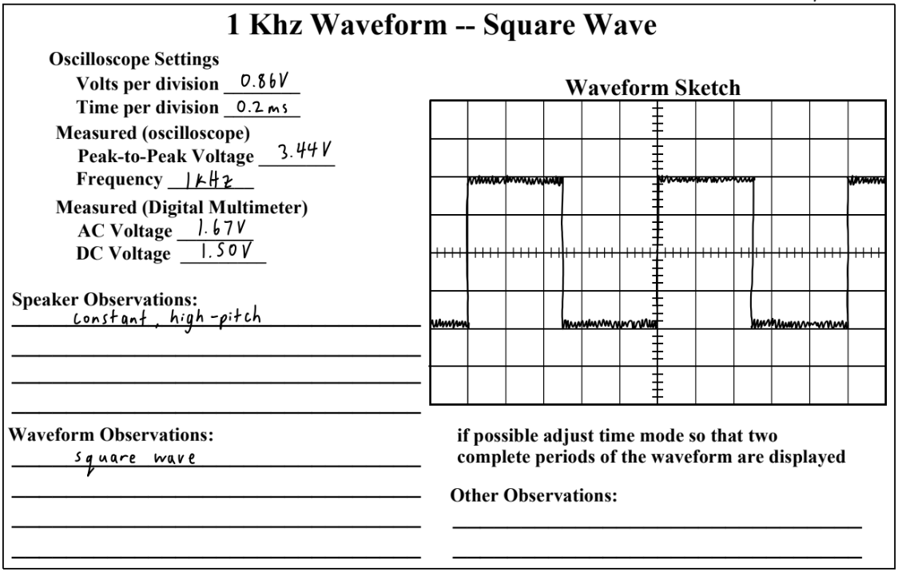

**Figure 9.** Square wave results

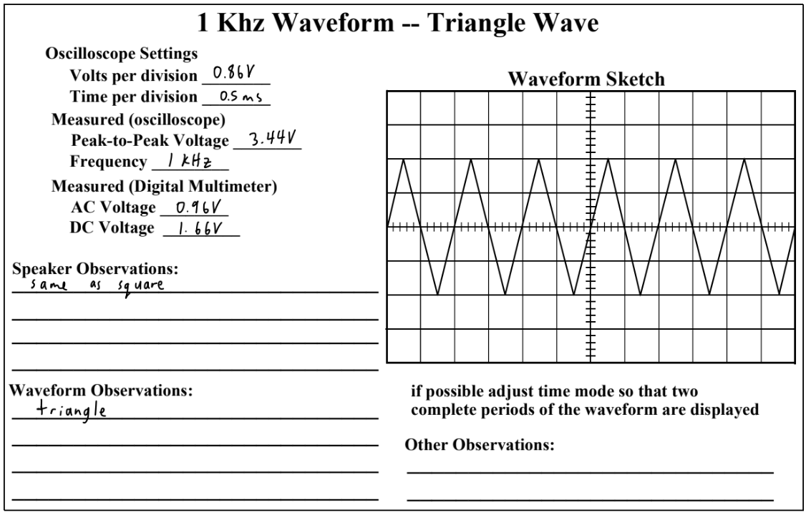

**Figure 10.** Triangle wave results

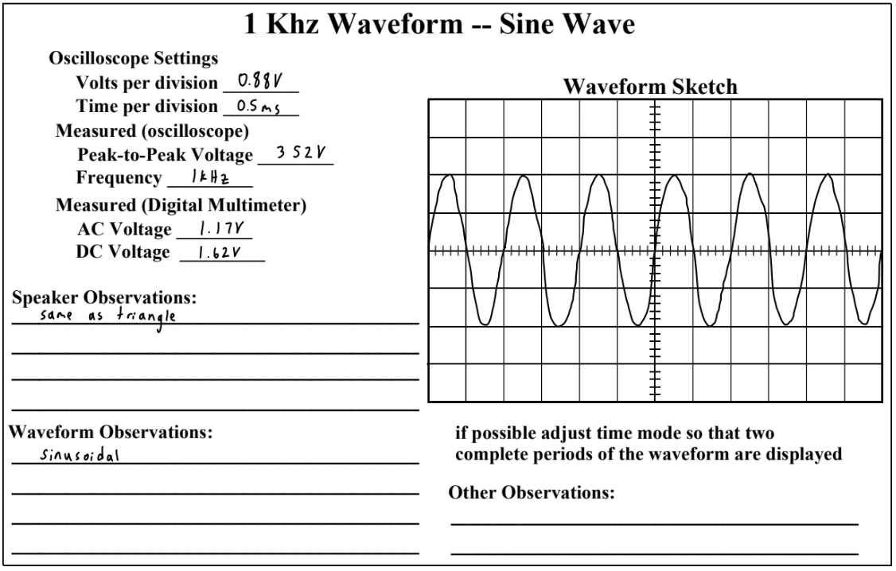

**Figure 11.** Sine wave results

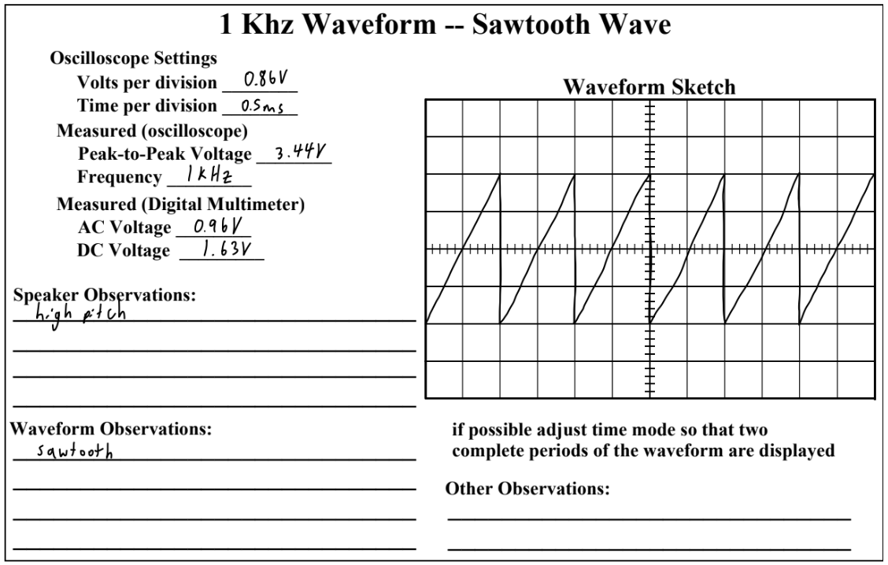

**Figure 12.** Sawtooth wave results

Questions

1. What is the effect of varying the switches SW17 through SW10?

Turning a switch off, reduces the peak-to-peak voltage, which in turn reduces the volume of the audio coming from the speaker. Altering the position of higher number switches (more significant bits) resulted in greater changes in voltage.

1. What is the effect of varying the switches SW9 through SW0 and KEY3/KEY2?

Turning off a switch reduces the frequency of the signal, resulting in a lower pitch sound coming from the speaker. More significant switches resulted in greater changes than lower ones such as the keys.

1. What is the slowest frequency signal that can be produced?

The slowest frequency signal that could be produced was 0 Hz with all the frequency switches set to logic low.

1. What is the highest frequency signal?

The highest frequency signal that could be produced was 4.08 kHz with all frequency switches set to logic high.

1. What is the frequency range that produces audio frequency that can be heard through the speaker?

The frequency range that produced audio frequency that could be heard through the speaker was about 1 Hz to 4.08 kHz.

1. When the digital multimeter is in the AC mode, does it measure RMS voltage or something else? What about when it is in DC mode? If it does not measure RMS voltage then what does it appear to measure?

When the digital multimeter is set to AC mode, it measures the RMS voltage of the AC signal. When it is in DC mode, it measures the average voltage or steady-state voltage of the DC signal.

1. How close was the measured frequency to 1 kHz? Explain what could be causing any differences between measured and the frequency that the design is supposed to produce?

The measured frequency was close to 1 kHz with switches 1, 3, 4, 5, 6, and 7 set. On occasion it would be off by 1 Hz, where it would be closer to 1 kHz when SW0 was also pressed. Any differences between the measured and the frequency that the design is supposed to produce could be due to external interferences from imperfections in the system that add noise or distortion to the signal. It could also be due to the calibration of the equipment or the handling of the resistance of the components.

Part B: Audio Generator (8 KHz Sample Rate)

The results of our audio generator experiment were successful, as we could hear the loaded audio playing from the speaker.

Question

1. Given the size of the Altera Cyclone IV E EP4CE115F29C7 FPGA assuming that all the audio memory is stored in embedded RAM and not created from other FPGA logic elements, what is the maximum length (un-compressed) that can be supported for both the 8 bit case and the 16 bit case without exceeding the avail- able resources?

The Altera Cyclone IV E FPGA has 3,981,312 memory bits available.

For the 8-bit case, we divide the total number of memory bits by the number of bits per sample and the sampling rate to get the maximum length in seconds of audio clip supported. Maximum length of audio clip that can be supported at 8 kHz and 8 bits = 3,981,312/(8*8000) ≈ 62 seconds. For the 16-bit case: 3,981,312/(16*8000) ≈ 31 seconds. These calculations are based on rough estimates and actual results may vary depending on the specific design and resource utilization.

Part C: Amplitude Modulation of a Radio Frequency Wave

We successfully observed the signal waveform modulation of the lower frequency sampled audio wave with the RF sine wave of higher frequency as observed in Figure 13 below.

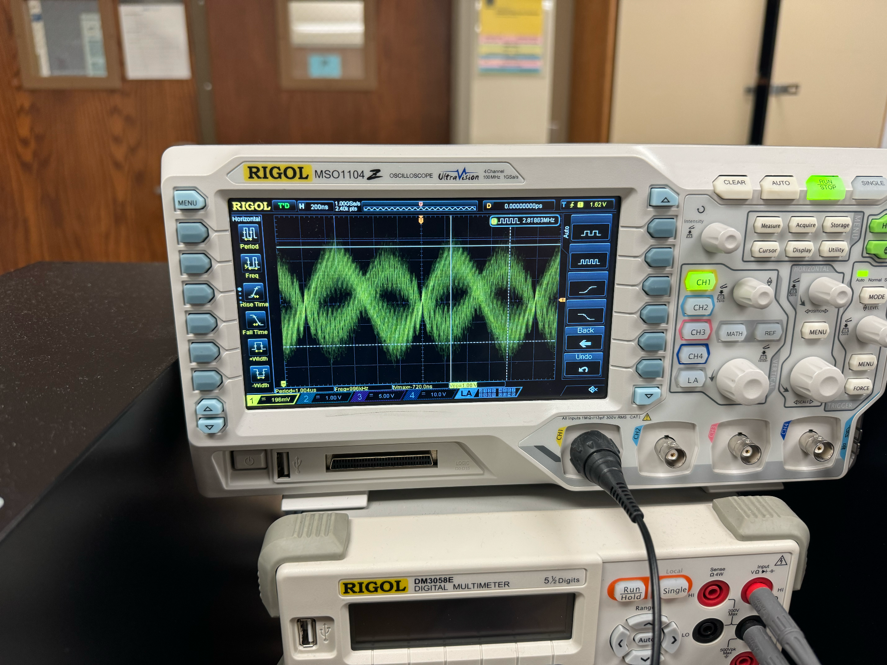

**Figure 13.** Modulated waveform

Questions

1. Why was signed arithmetic used in the PDM task? How might signed arithmetic help in terms of modeling the problem?

Signed arithmetic was used in the pdm task because it ensures that both positive and negative amplitudes are accurately represented, allowing the input signal to be reproduced effectively.

1. What are the advantages and disadvantages of floating point arithmetic as opposed to integer or fixed-point arithmetic in digital hardware? What favored the use of fixed point in this design?

The advantage of using floating point arithmetic as opposed to integer or fixed-point arithmetic in digital hardware is greater precision resulting in increased dynamic range since a larger range of values can be represented. The disadvantage is that there is greater complexity involved, requiring more resources and costs to handle floating point values.

Fixed point was favored in this design simplicity and sufficient precision for our use case. It allowed us to use our digital signal processing effectively while not utilizing an excessive amount of resources in the hardware.

1. Why are lookup tables often used to generate sine waves? Why not just compute on the fly using a numeric methods to generate the sine function?

Lookup tables are often used to generate sine waves because they are a fast and efficient method of retrieving precomputed values, allowing for direct access during runtime rather than having to complete many computations resulting in latency. This is why lookup tables can be preferable to on the fly numeric methods to generate the sine function.

1. Conclusion

Through the exploration of digital hardware and signal processing techniques, we successfully designed and implemented an analog waveform generator capable of producing various waveforms, an audio generator for playback of pre-recorded audio, and an amplitude modulation scheme for radio frequency transmission. By leveraging concepts such as pulse density modulation and fixed-point arithmetic, we achieved efficient and accurate representation of audio signals within the constraints of the Altera Cyclone IV E FPGA. The use of lookup tables for sine wave generation facilitated real-time processing while minimizing computational overhead. Overall, this laboratory experiment provided valuable insights into digital signal processing methodologies and their practical application in creating complex analog waveforms and modulation schemes using FPGA-based systems.

1. Appendix

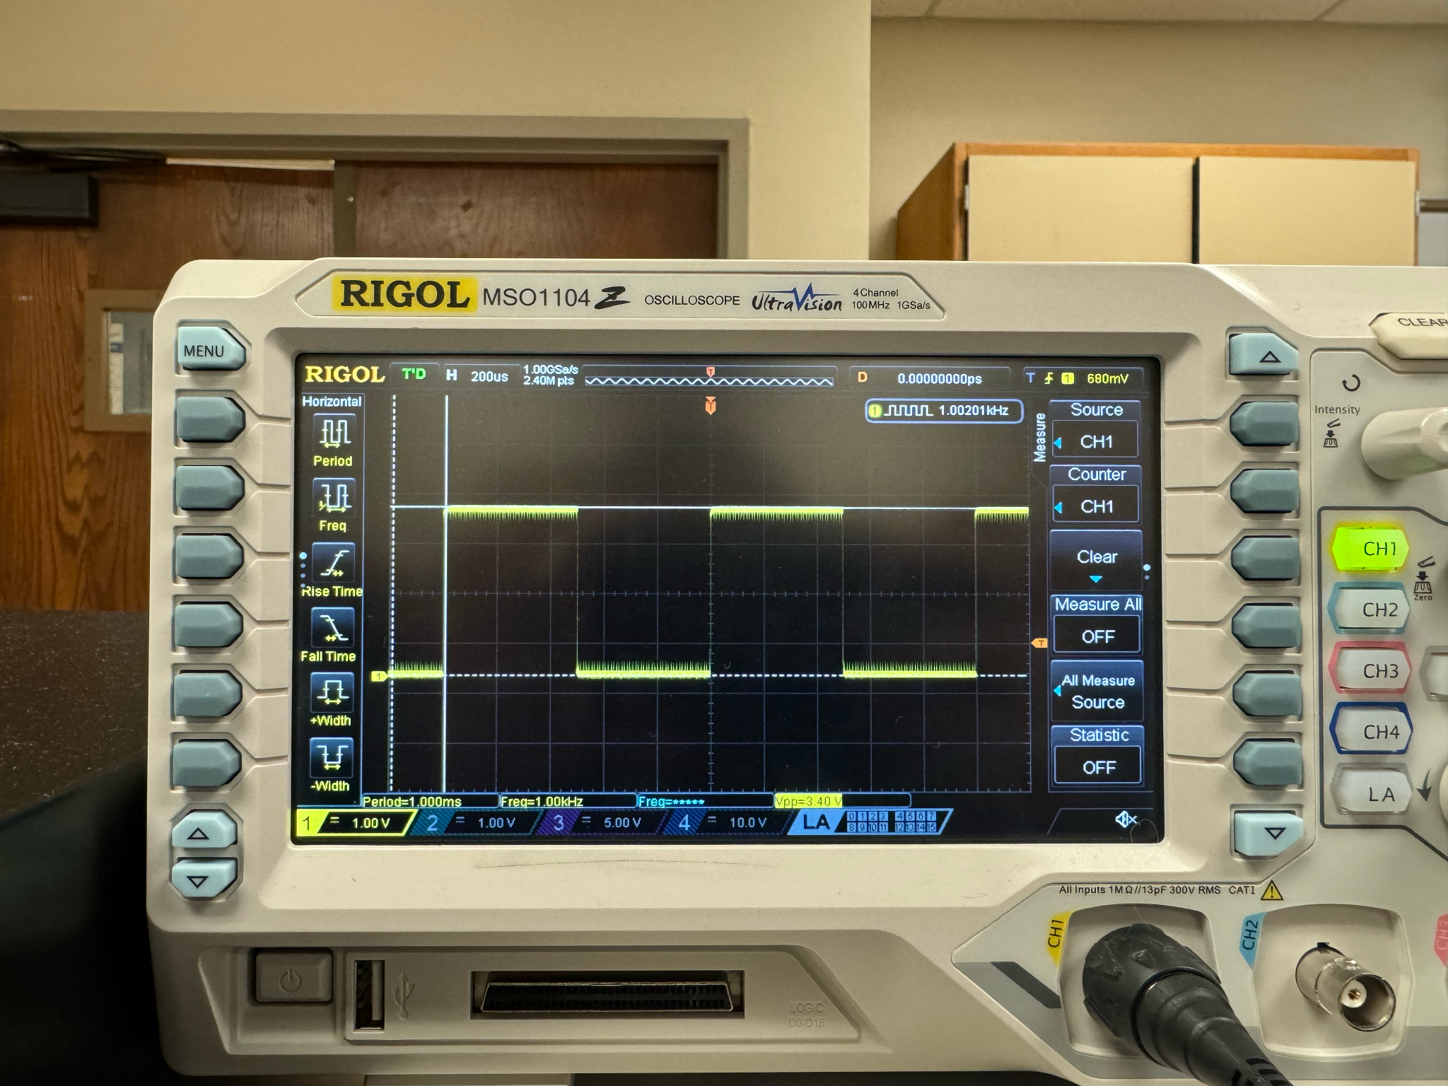

**Figure 14.** Square wave

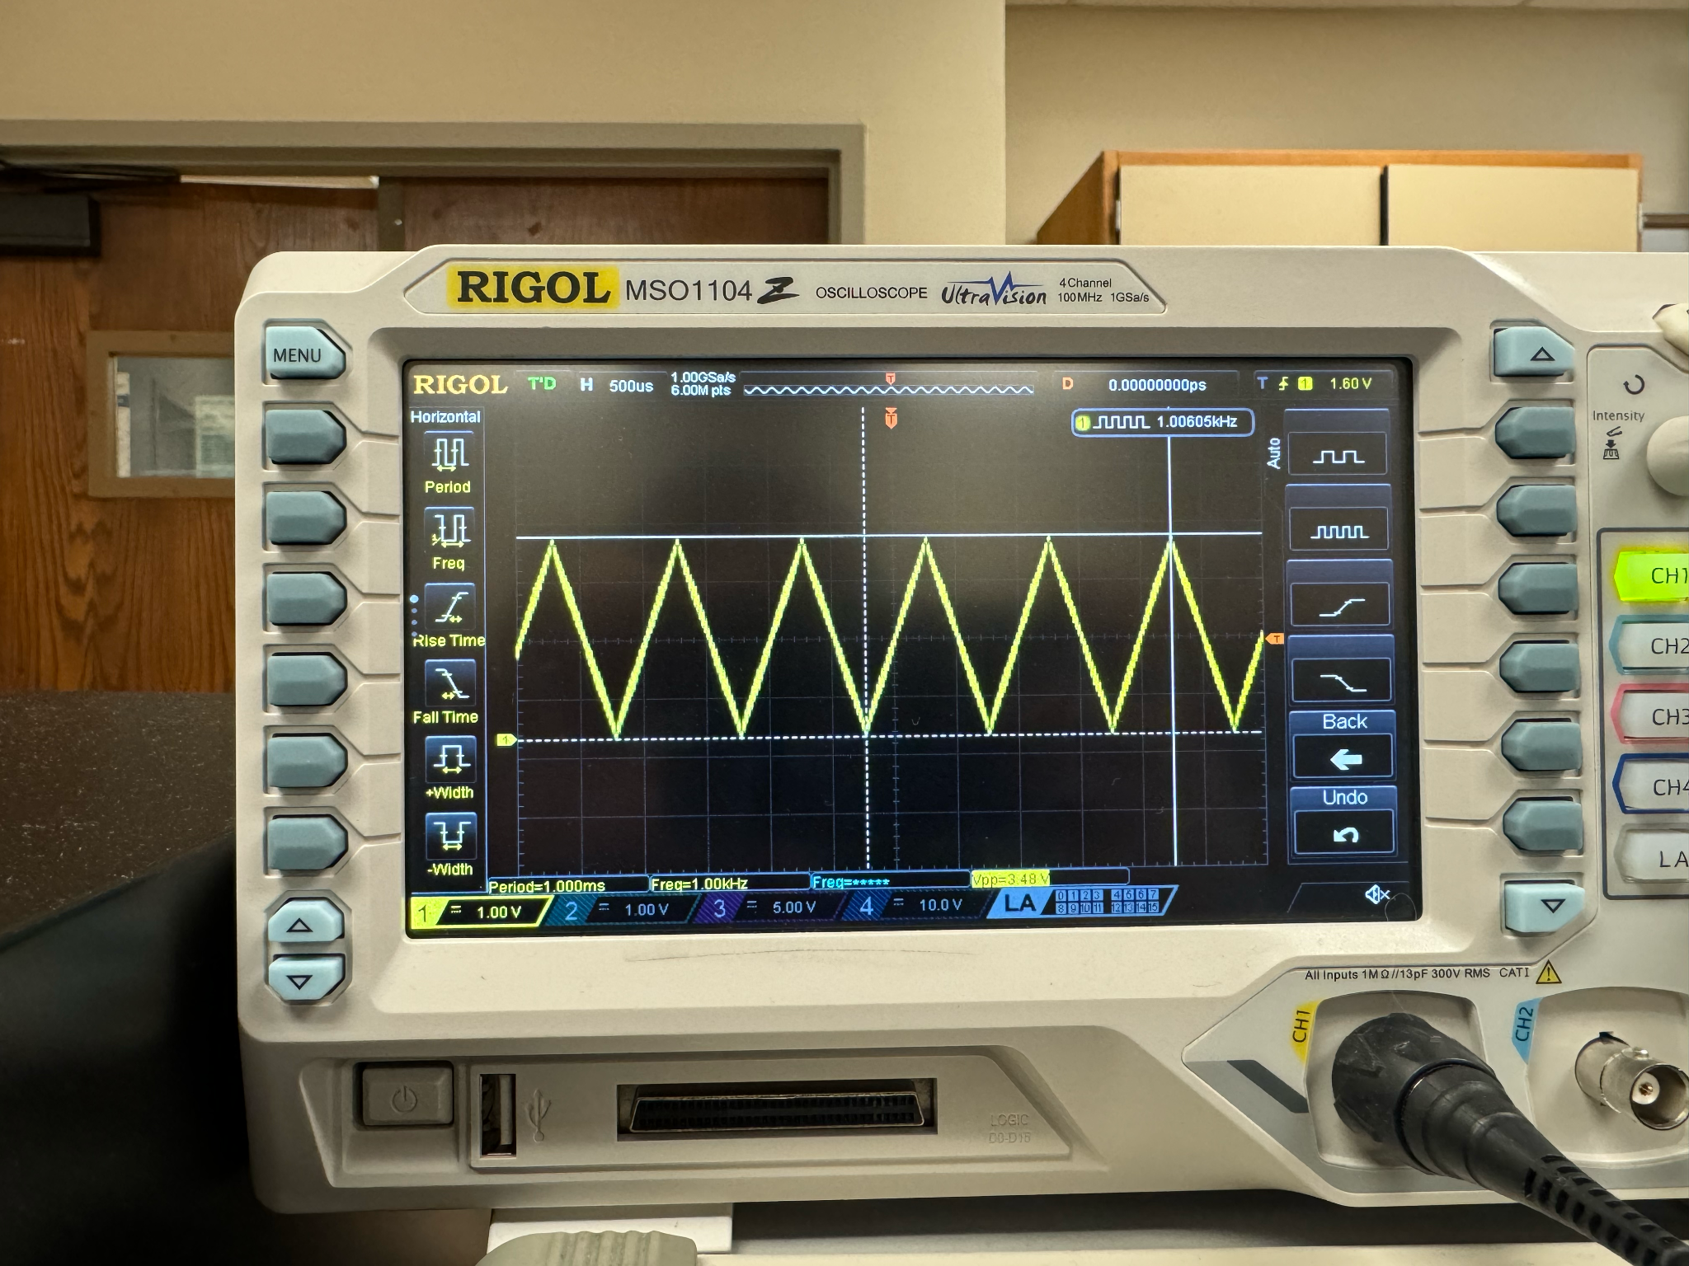

**Figure 15.** Triangle wave

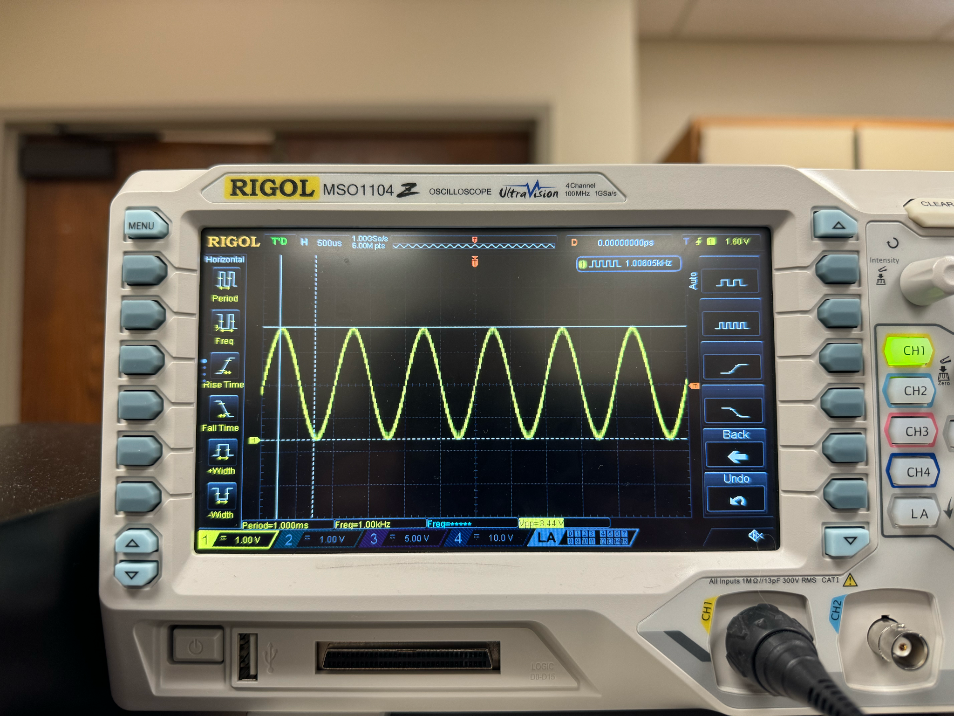

**Figure 16.** Sine wave

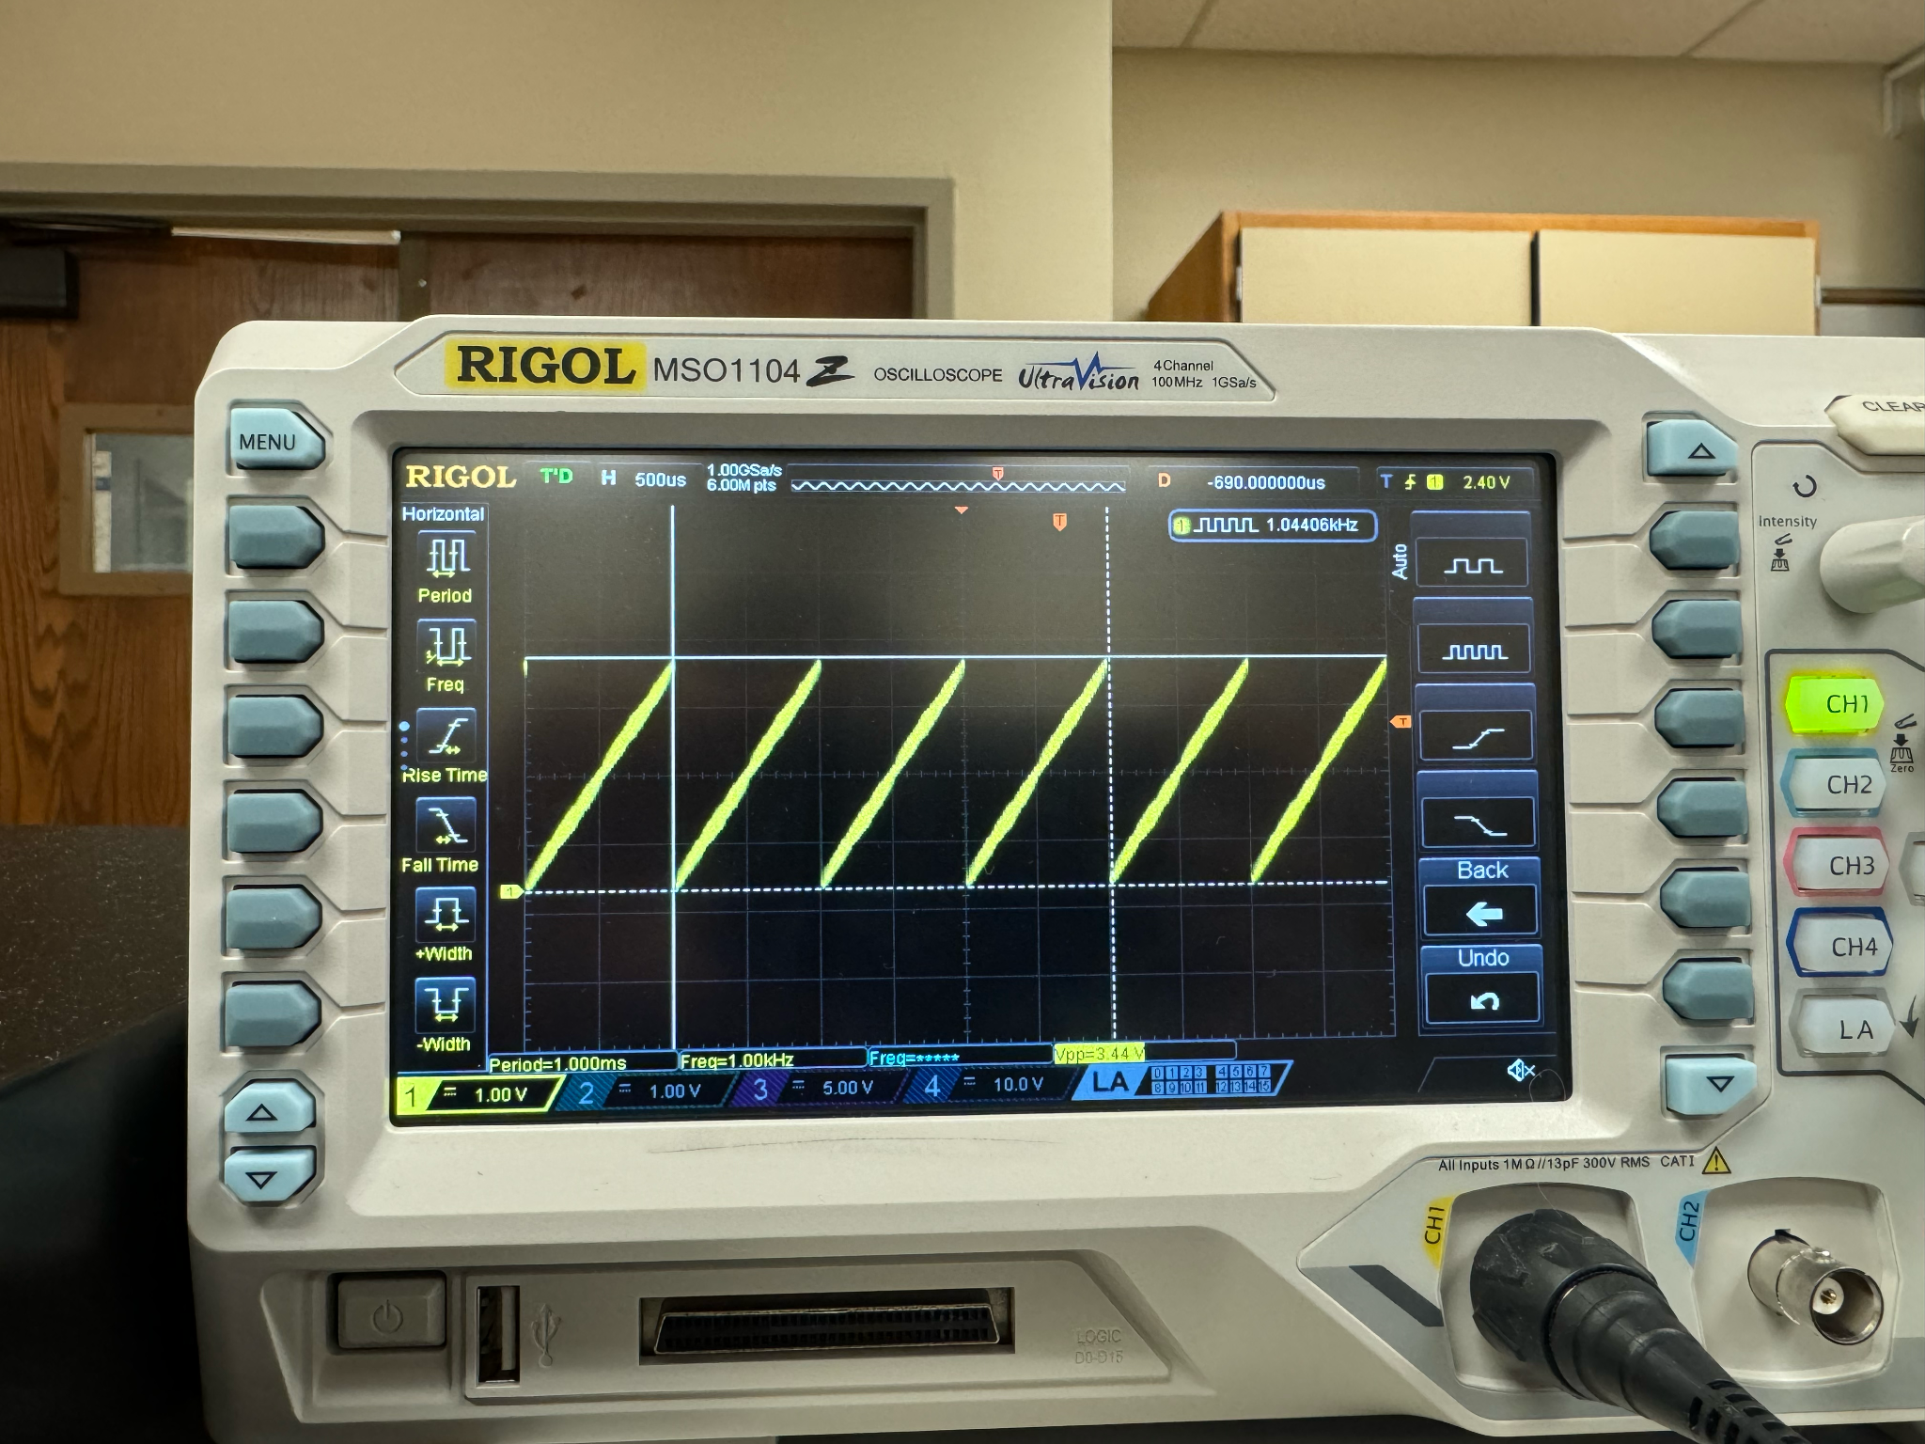

**Figure 17.** Sawtooth wave